THE UPPER LIMBS


The Islamic University College of Medical Technologies Department of Radiology Technologies
First Stage
Lecture two: The Upper Limbs
MSC:Tariq Mohammed Alshybany /MSC:Mohammed.K.S.Alquraishi. MSC:Ali nahed Abdu Alameer

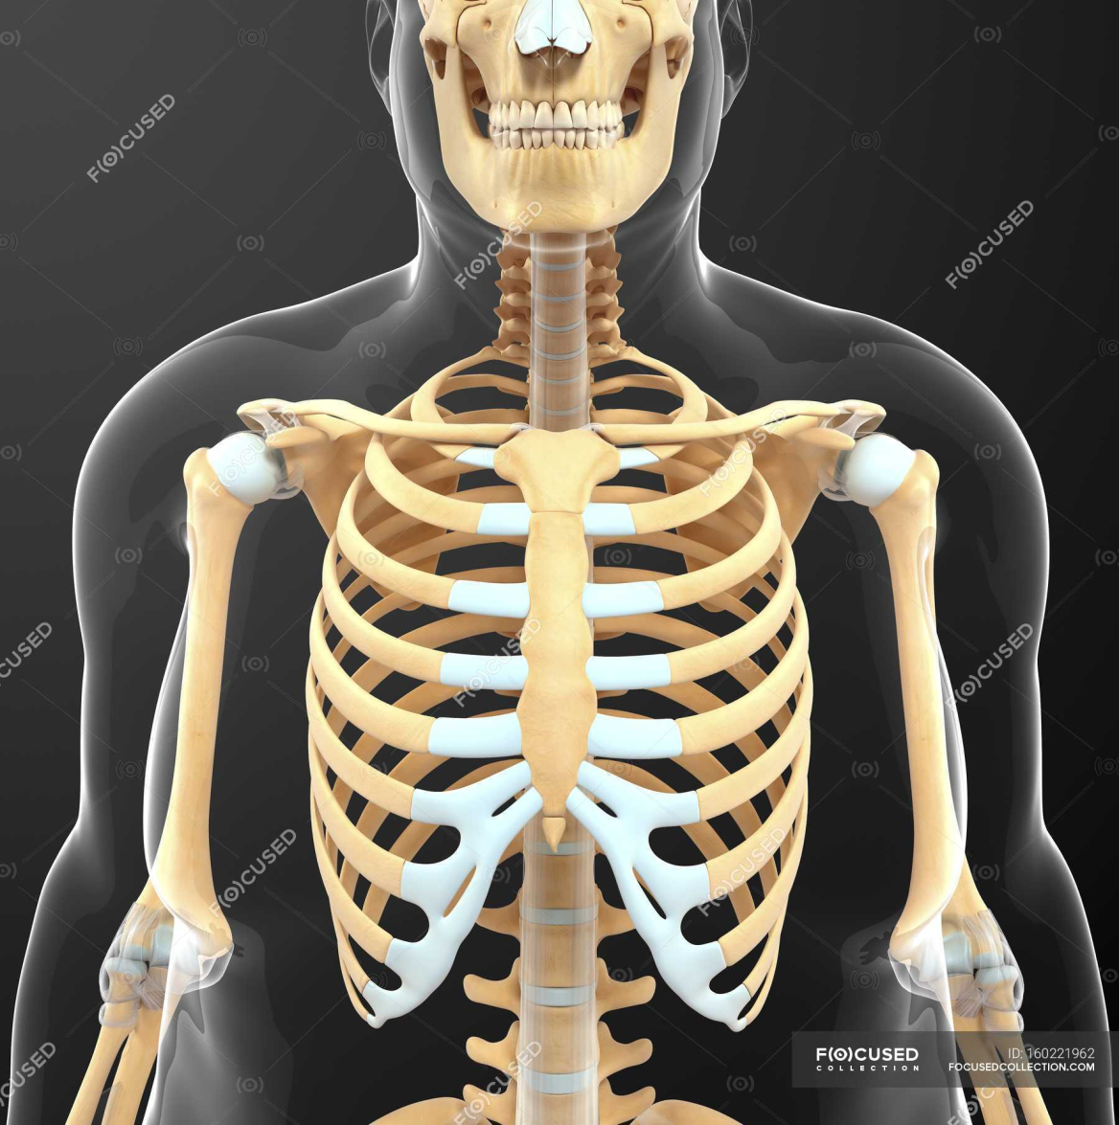
Themes of the lecture:-

1- Introduction to upper limbs.
2- Pectoral Girdle.
3- Articulations of Clavicle.
4- The upper limb muscles.
5 Triceps brachii.

The purpose of the lecture:-

(Introducing the student to the upper limbs and muscles of upper limbs)

Behavior Objectives:-

1- To know the definition of the upper limbs.
2- In order for the student to learn the details of upper limbs.
3- The student should be able to know scientific names of upper limbs.
4- The student be able to differentiate bones and muscle of upper limbs.
5- The student enumerates all parts of upper limbs and it muscles.

References of the lecture:-

https://books.google.iq/books?id=aK52DwAAQBAJ&printsec=frontcover&dq=general+anatomy+book+pdf&hl=ar&sa=X&redir_esc=y#v=onepage&q&f=false

https://books.google.iq/books?id=6bZEDwAAQBAJ&printsec=frontcover&dq=general+anatomy+book+pdf&hl=ar&sa=X&redir_esc=y#v=onepage&q&f=false

The Bones of UL are:
Pectoral Girdle.
Arm : Humerus.
Forearm : Radius & Ulna.
Wrist : Carpal bones
Hand: Metacarpals& Phalanges

Pectoral Girdle

*Formed of Two Bones:
*Clavicle (anteriorly) and Scapula (posteriorly).
*It is very light and allows the upper limb to have exceptionally free movement.

Clavicle

It is a long bone with no medullary cavity.
It has the appearance of an elongated letter Capital (S) lying on one side.
It has Two Ends:
Medial (Sternal): enlarged & triangular.
Lateral (Acromial) : flattened.
Body (shaft):
*Its medial 2/3) is convex forward.
*Its lateral 1/3 is concave forward.
*Surfaces:
*Superior : smooth as it lies just deep to the skin.
*Inferior: rough because strong ligaments bind it to the strib.

Articulations of Clavicle

*Medially with the manubriumat the Sternoclavicular joint .
*Laterally with the Scapula at the Acromioclavicular joint
*Inferiorly with the strib at the Costoclavicular Joint

Scapula (Shoulder Blade)

It is a triangular Flat bone.
*Extends between the 2nd _ 7th ribs.
*It has :
*Three Processes:
*(1)Spine: a thick projecting ridge of bone that continues laterally.
*(2) Acromion: forms the subcutaneous point of the shoulder.
*(3) Coracoid: a beak like process.
*It resembles in size, shape and direction a bent finger pointing to the shoulder.
*Three Borders: Superior, Medial (Vertebral) & Lateral (Axillary) (the thickest) part of the bone, it terminates at the lateral angle .

*Three Angles :
*Superior.
*Lateral(forms the Glenoidcavity) : a shallow concave oval fossa that receives the head of the humerus.
*Inferior.
*Two Surfaces:
1.Convex Posterior : divided by the spine of the scapula into the
Smaller Supraspinous Fossa
*(above the spine) and the
*larger Infraspinous Fossa
*(below the spine).

2.Concave Anterior (Costal): it forms the large Subscapular Fossa.

Humerus

*A typical Long bone.
*It is the largest bone in the UL
*Proximal End :
*Head, Neck, Greater & Lesser Tubercles.
*Head:Smooth
*it forms 1/3 of a sphere, it articulates with the glenoid cavity of the scapula.
*Greater tubercle: at the lateral margin of the humerus.
*Lesser tubercle: projects anteriorly.
*The two tubercles are separated by
*Intertubercular Groove.
*Anatomical neck: formed by a groove separating the head from the tubercles

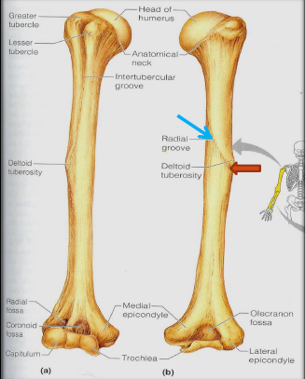

*Shaft (Body):
*Has two prominent features:
1. Deltoid tuberosity:
A rough elevation laterally for the attachment of deltoid muscle.
2. Spiral (Radial) groove:
Runs obliquely down the posterior aspect of the shaft.
It lodges the important radial nerve & vessels.
*Distal End:
Widens as the sharp medial and lateral Supracondylar Ridges and end in the Medial (can be felt) and Lateral Epicondyles.
They provide muscular attachment.

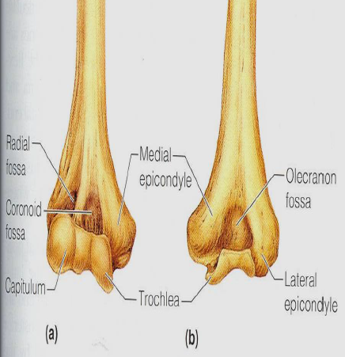

Structures at Distal end:
*Anteriorly:
Trochlea:(medial) for articulation with the ulna
Capitulum:(lateral) for articulation with the radius.
*Coronoid fossa :above the trochlea.
*Radial fossa:above the capitulum.
Posteriorly:
Olecranon fossa :above the trochlea.


Ulna

It is the stabilizing bone of the forearm.
It is the medial & longer of the two bones of the forearm.
Proximal End
1. Olecranon Process :
projects proximally from the posterior aspect(forms the prominence of the elbow).
2. Coronoid Process :
projects anteriorly.
3.Tuberosity of Ulna:
inferior to coronoid process.
4.Trochlear Notch:
articulates with trochleaof humerus.
5.Radial Notch :
a smooth rounded concavity lateral to coronoid process.

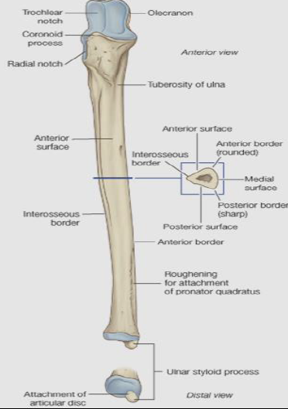
Shaft:
*Thick & cylindrical superiorly but diminishes in diameter inferiorly
*It has Three Surfaces (Anterior, Medial & Posterior).
*Sharp Lateral Interosseous border.
*Distal End: Small rounded
1. Head:lies distally at the wrist. .
2. Styloid process:Medial.

Radius

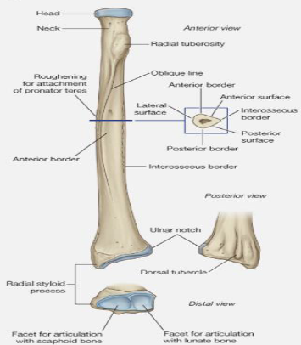

It is the shorter and lateral of the two forearm bones.
Proximal End:
1. Head: small & circular
Its upper surface is concave for articulation with the Capitulum.
2. Neck.
3. Radial (Biciptal) Tuberosity: medially directed and separates the proximal end from the body.
Shaft:
Has a lateral convexity.
It gradually enlarges as it passes

The upper limb muscles
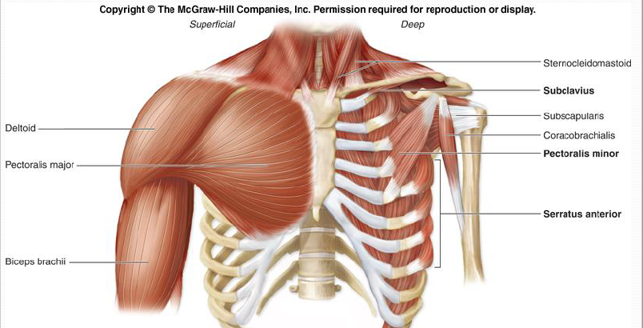

The Muscles of Upper Limb

Muscles of shoulder
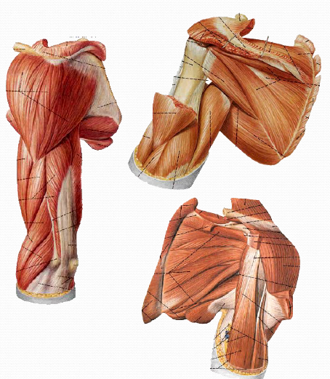
1-Deltoid
2-Supraspinatus
3-Infraspinatus
4-Teres minor
5-Teres major
6-Subscapularis

Major muscles of shoulder

Deltoid
*Origin: lateral third of clavicle,
acromion, and spine of scapula
*Insertion: deltoid tuberosity
of humerus
*Action: flexion and
extension, medial and lateral
rotation of arm

Major muscles of shoulder

Teres major
*Origin: dorsal surface of
inferior angle of scapula
*Insertion:crest of lesser tubercle
of humerus
*Action:medially rotates and
adducts arm

Arm Arm and Forearm Muscles That Move the Elbow Joint/Forearm

1-Anterior (flexor) compartment
2-Posterior (extensor) compartment
3-Anterior compartment
4-primarily contains elbow flexors
5-Posterior compartment contains elbow extensors
6-the principal flexors
7-biceps brachii, brachialis, and brachioradialis
8-muscles that extendthe elbow joint
9-triceps brachii and anconeus.

Antererior group

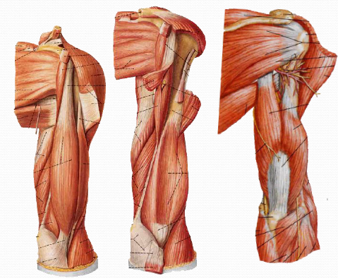
1-Biceps brachii
2-Coraco brachialis
3-Brachialis
Posterior group

1-triceps brachii
2-anconeus

MMuscles of arm

Biceps brachii
*Origin: long head, supraglenoid
tubercle; short head, coracoid process
*Insertion: radial tuberosity
*Action: supinator of forearm,
flexor of elbow joint, weak flexor
of should joint

Muscles of arm

Triceps brachii
*Origin:
long head, infraglenoid tubercle
lateral head, above groove
for radial nerve
medical head, below groove
for radial nerve
*Insertion:olecranon of ulna
*Action:extends elbow joint,
long head extends and adducts
shoulder joint

Triceps brachii
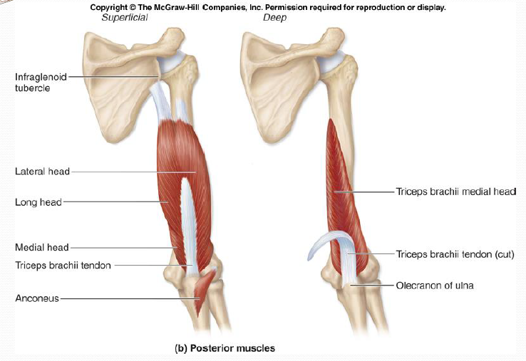

Muscles of forearm

Superficial layer
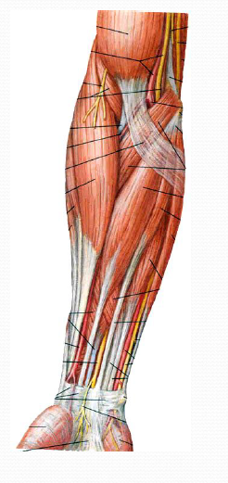
1-Pronator teres
2-Flexor carpi radialis
3-Palmaris longus
4-Flexor carpi ulnaris

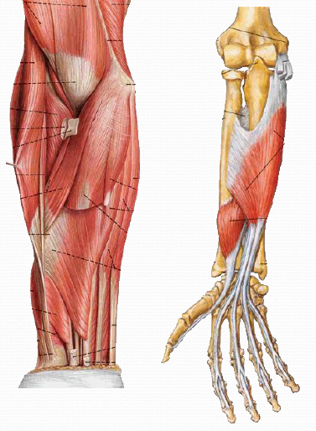

Second layer
Flexor digitorum superficials

Third layer
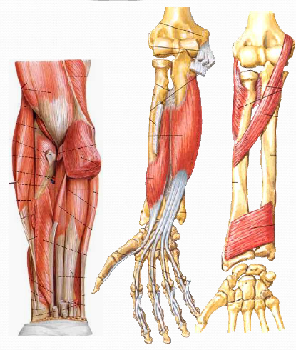
1-Flexor digitorum profundus
2-Flexor pollicis longus
Fourth layer
Pronator quadratus
Action: flex radiocarpal joint
and fingers, pronate forearm

