Islamic University College
of Medical Technologies / Department
of Radiation Techniques
Introduction to radiographic anatomy
Lecture-1-

Dr. Safaa AL-Mosawy
M S C . Tariq Mhummed

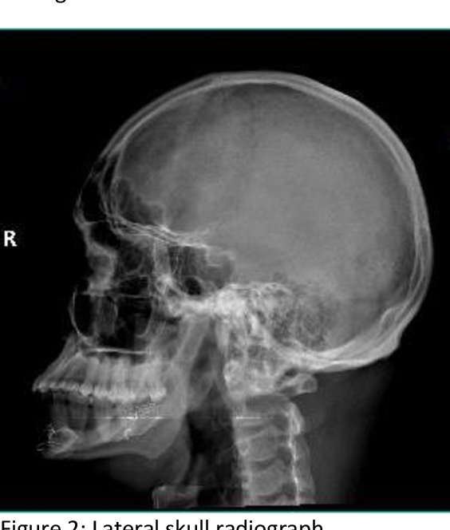

The cranium consists of the following bones, two of which are paired :
■■ Frontal bone: 1
■■ Parietal bones: 2
■■ Occipital bone: 1
■■ Temporal bones: 2
■■ Sphenoid bone: 1
■■ Ethmoid bone: 1
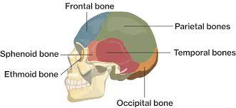

The facial bones consist of the following, two of which are
Single :
■■ Zygomatic bones: 2
■■ Maxillae: 2
■■ Nasal bones: 2
■■ Lacrimal bones: 2
■■ Vomer: 1
■■ Palatine bones: 2
■■ Inferior conchae: 2
■■ Mandible: 1
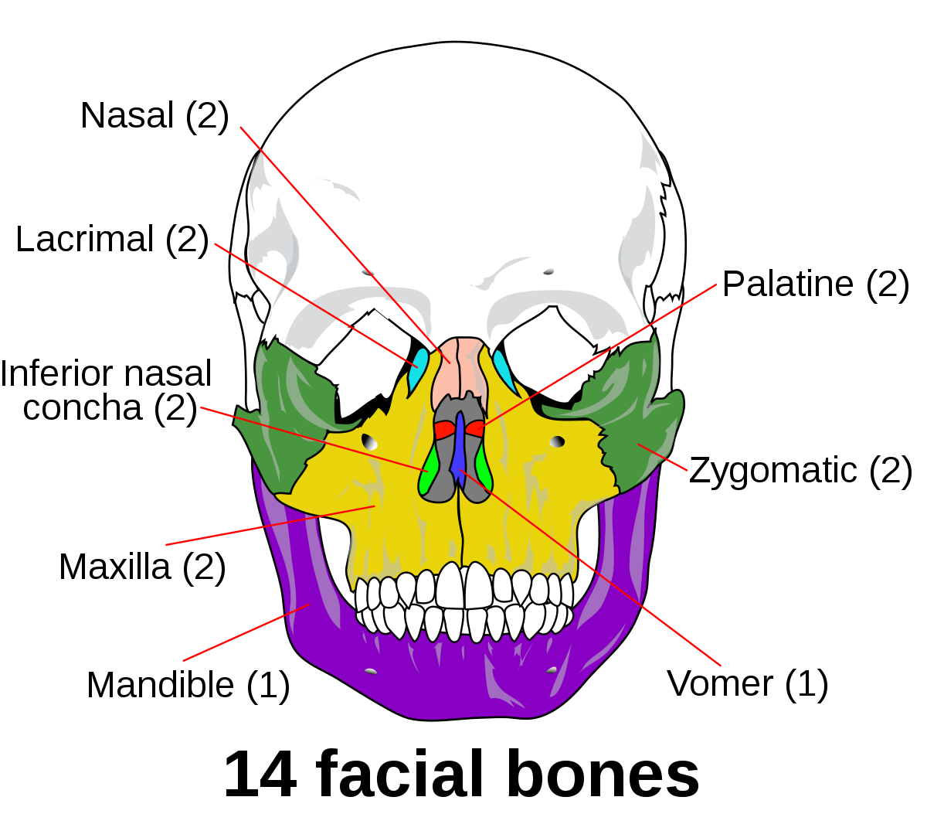

Gross anatomy:

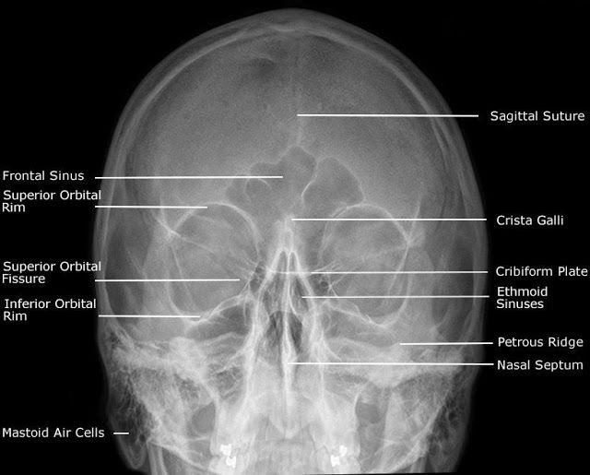

PARIETAL BONE

The parietal bone is a paired, irregular, quadrilateral skull bone that forms the sides and roof of the cranium.
Gross anatomy
The parietal bone has four borders, four angles, and external/internal surfaces.
Borders include: frontal, sagittal, occipital (half of lambdoid suture), and squamous temporal.
Angles include: sphenoid, mastoid, occipital, and frontal. The external surface is convex and smooth. It features:
parietal eminence
superior temporal line for attachment of temporalis fascia
inferior temporal lines for attachment of temporalis muscle
parietal foramen contains an emissary vein to superior sagittal sinus
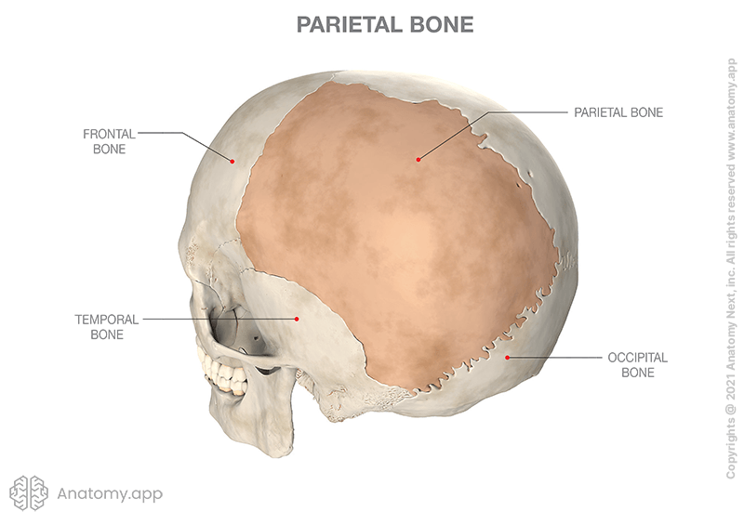

THE TEMPORAL BONE
The temporal bone is situated on the sides and the base of the cranium and lateral to the temporal lobe of the cerebrum. The temporal bone is one of the most important calvarial and skull base bones. The temporal bone is very complex and consists of five parts:
1-squamous part
2- mastoid part
3- petrous part
4- tympanic part
5- styloid process (or part)
Some anatomists describe only 4 parts of the temporal bone, with the mastoid and petrous parts combined as a petromastoid part .
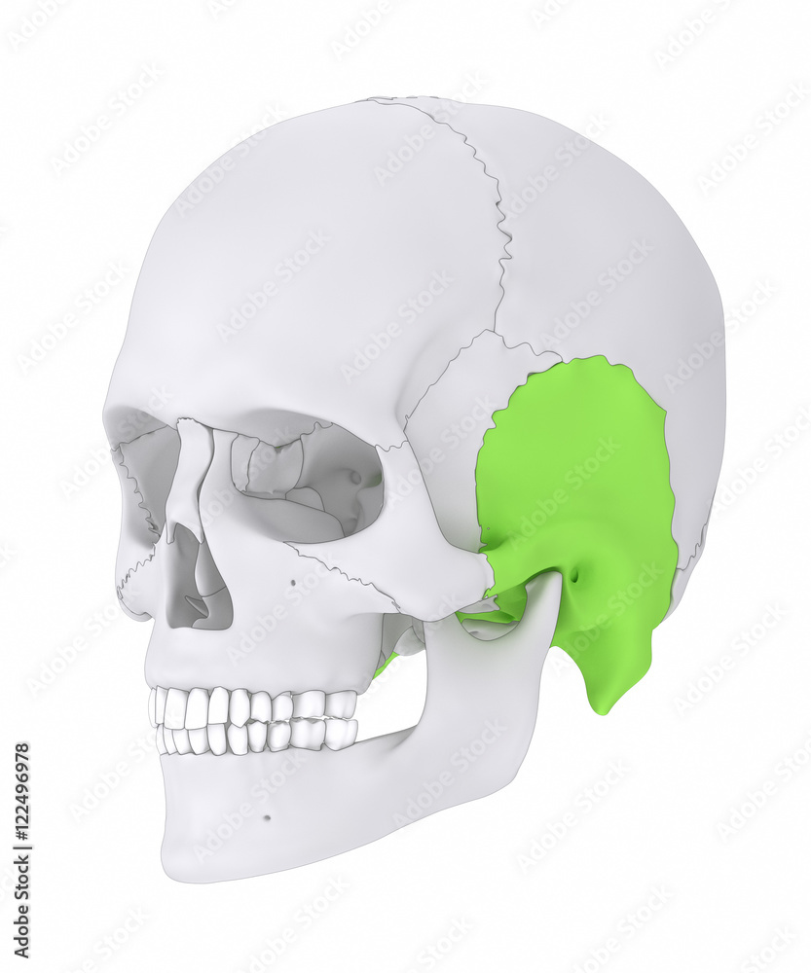

THE SPHENOID BONE

The sphenoid bone is a large complex unpaired bone ofthe skull base.
Gross anatomy
Parts of the sphenoid bone include:
body
greater wing
lesser wing
Articulations
The sphenoid bone articulates with twelve bones:
• ***unpaired bones include: frontal, ethmoid, vomer, and occipital
paired bones include: zygomatic, parietal, temporal, and palatine.**
Fissures, foramina, grooves and canals OF The sphenoid bone includes:
optic canal
•superior orbital fissure
foramen rotundum
pterygoid canal
foramen ovale
foramen spinosum
carotid groove
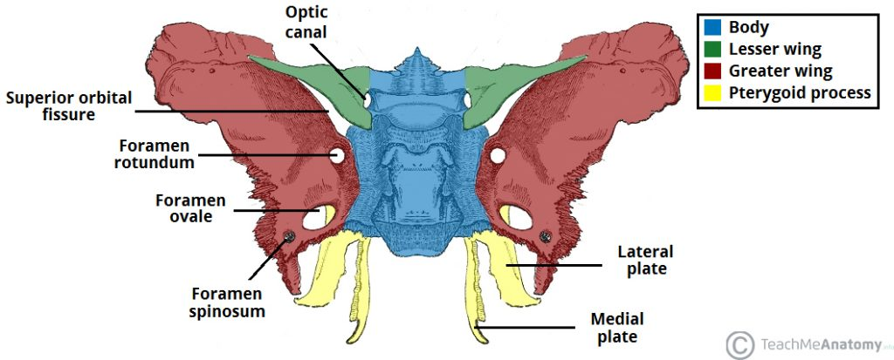
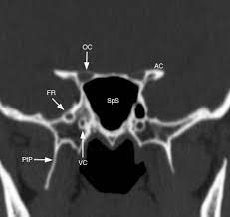
The OCCIPITAL BONE
The occipital bone is a trapezoid skull bone that contributes to the posteroinferior part of the cranial vault. It is pierced by the foramen magnum, permitting communication from the cranial cavity to the vertebral canal
**Gross anatomy
The occipital bone is composed of four parts:
squamous part: external/internal surfaces
basilar part (basiocciput): lower/upper surfaces
lateral (jugular) parts (two): under/upper surfaces**
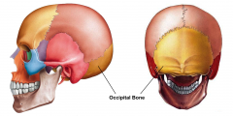

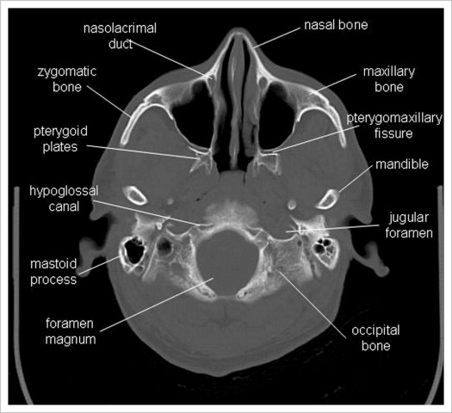

ETHMOID BONE
the ethmoid bone is a single midline facial bone that separates the nasal cavity from the brain and is located at the roof of the nose and between the orbits.
It is a cubical shape and is relatively lightweight because of its spongy construction.
It contributes to the anterior cranial fossa. Gross anatomy
The ethmoid bone consists of four parts:
horizontal (cribriform) plate vertical (perpendicular) plate 2 lateral masses (labyrinths)
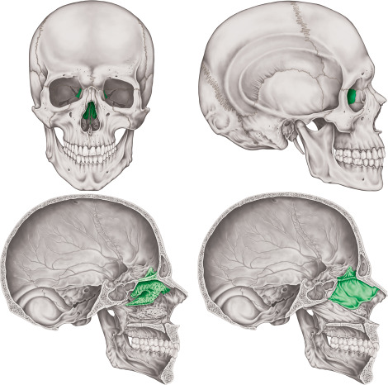

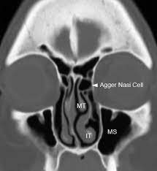

MANDIBLE BONE

THE MANDIBLE BONE
The mandible is the single midline bone of the lower jaw.
It consists of a curved, horizontal portion, the body, and two perpendicular portions, the rami, which unite with the ends of the body nearly at right angles (angle of the jaw). It articulates with both temporal bones at the mandibular fossa at thetemporomandibular joints (TMJ).
Gross anatomy
1-Body
2-Ramus
3-Coronoid process
4-Condylar processArticulations
Articulates with 15 bones in total (4 cranial bones and 11 facial bones
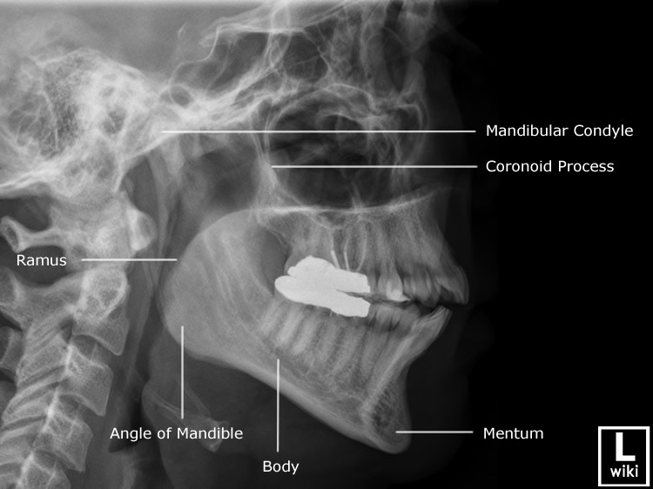

The maxillae bones

The maxillae bones
The maxillae (or maxillary bones) are a pair of symmetrical bones joined at the midline, which form the middle third of the face.
contains the maxillary sinus, and contributes most of the inferior rim and floor of the orbit. Its alveolar process houses the teeth.
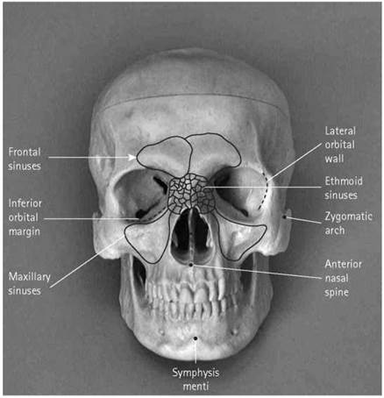

palatine bones
the palatine bones are paired L-shaped bones joined at the midline. They form the hard palate with the maxillary bones (the hard palate separates the oral cavity from the nasal cavity).
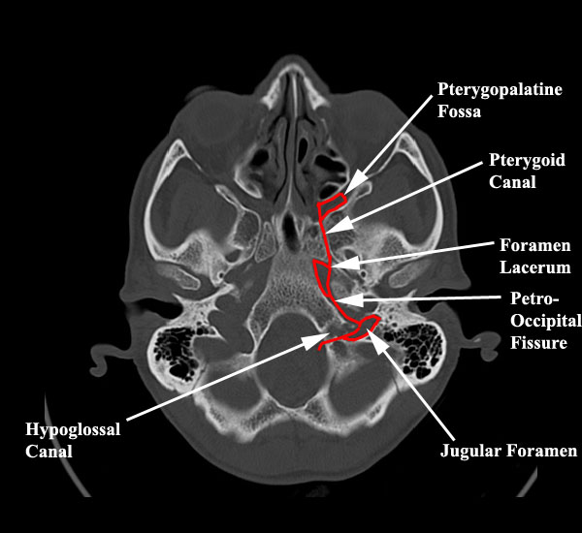

lacrimal bones
**The lacrimal bones are paired craniofacial bones forming anterior aspect of the medial orbital wall**
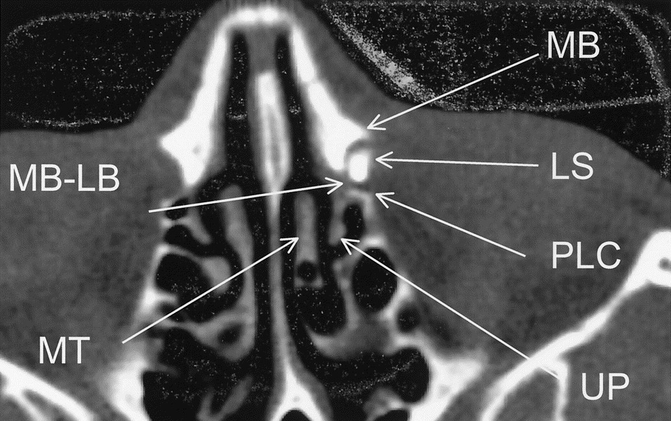

Zygoma bones
The zygoma (also known as zygomatic bone or malar bone) is
an important facial bone which forms the prominence of the cheek. It is roughly quadrangular in shape.
Gross anatomy
Zygoma has three surfaces, five borders, and two processes.
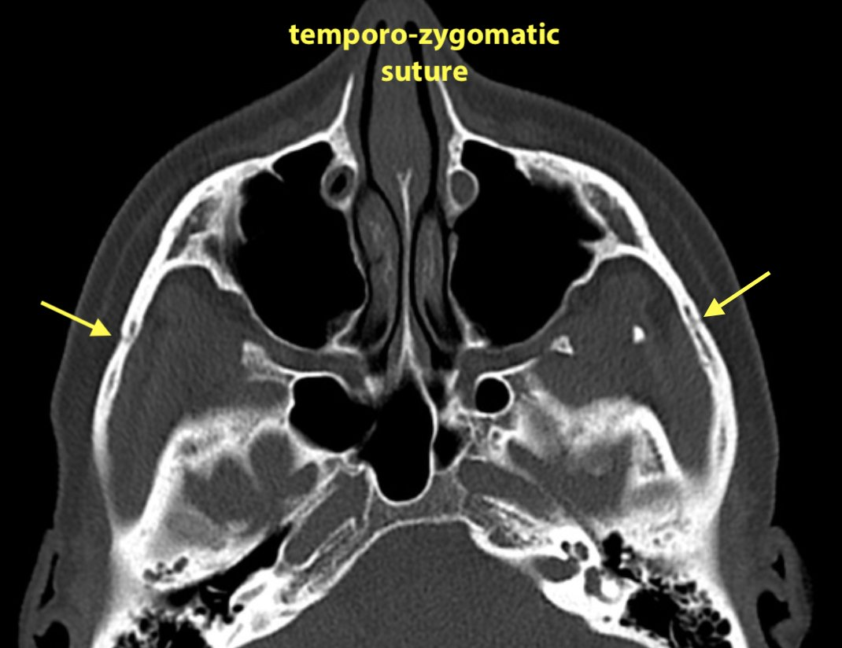

Nasal bones
The nasal bones are small paired oblong upper central facial bones placed side by side between the frontal processes of
the maxilla, jointly forming the nasal ridge.
