Computer Fundamentals

Getting To The Desktop

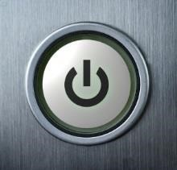
- To switch on a computer you use the power button, this is a universal symbol for how to power on devices. When you press this button your computer will start “booting up”. This means your computer is getting ready to be used and can take anything from 10 seconds to 5 minutes depending on the computer.
- Once the computer powers up after a short period of time you will come to a screen with a random artistic image as the background.

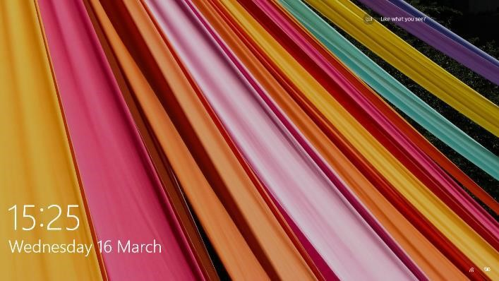

- Press the left mouse button once and it will disappear and be replaced with this. Click on “Sign in” with the left mouse button. If you have a password type it into the box that appears and click the arrow button. (If there isn’t a password created it will just sign in straight away).
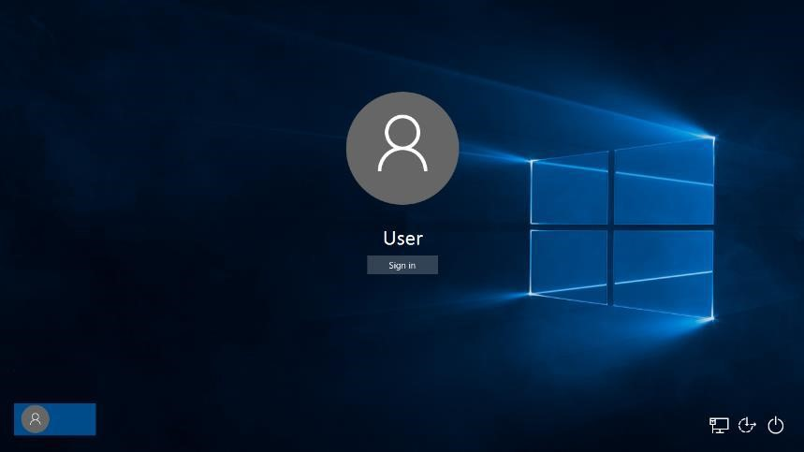

- Windows will now load up and you will eventually come to a screen called the Desktop.
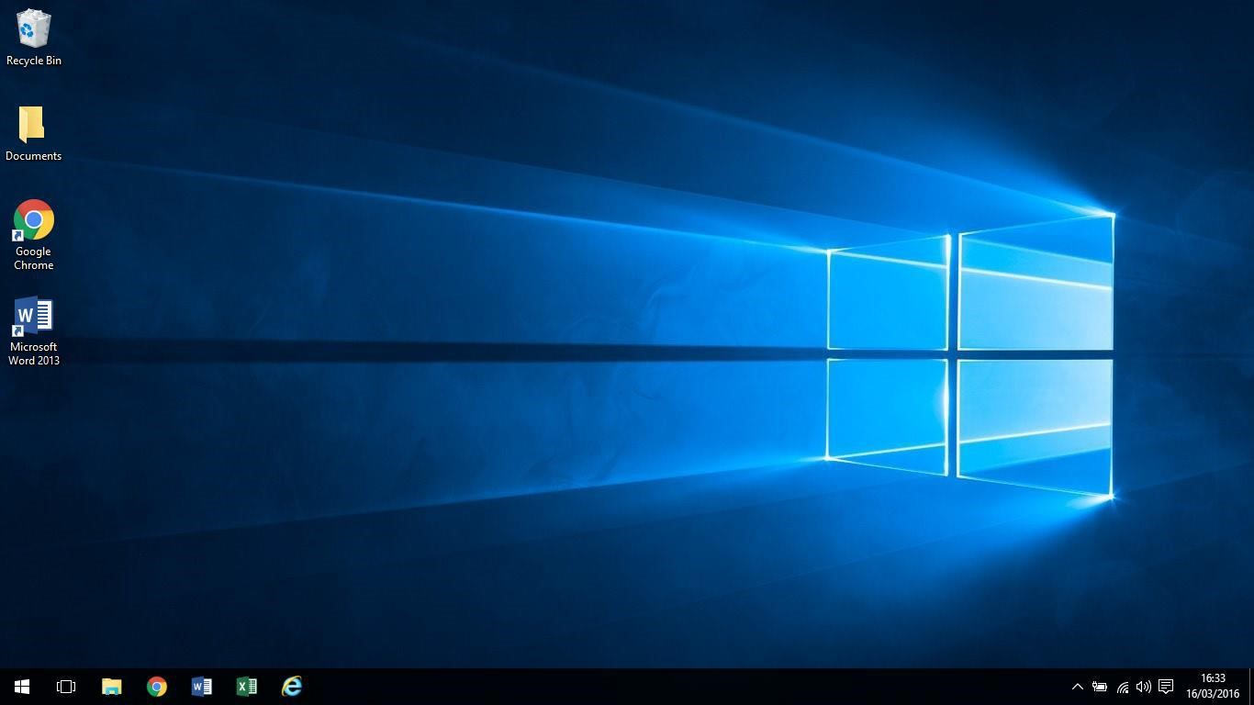

The Desktop is split into two areas. The strip at the bottom, with the clock to the right and the square, window shaped Start button to the left, is called the Taskbar. We will explore this area in a different section. But here's a closer look at it. The rest of the Desktop is the space where all your programmes will appear when you start them up. This space contains default background wallpaper, but it can also contain shortcuts to programmers, documents and folders.
Desktops can be customized and can look different depending on which computer you’re using. For example a public network like the library may have a computer setup to use their own logo on the Desktop and use different software to access the internet. What is best to do is take your time to familiarize yourself with the computer you are using.
Imagine your Desktop is just that the top of a desk, computers are designed around the working world the office in particular. The Desktop was designed so you have everything at hand just like sitting at your desk.

Icons and folders
You can customise your Desktop by adding Icons or keeping the files you are currently working with on the Desktop. But for the moment you will have to get familiar what these Icons and files look like. Icons are symbols for what programs you want to launch from your Desktop, There should be some Icons and folders on your Desktop

These are Web Browsers we use for browsing the internet so we can visit websites and search for information – we’ll look at these in detail in another lesson.

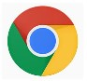

Check the computer you are using to see what is on the Desktop, it may even have them all

There are also other Icons, you can create Icons “ Also Known As Shortcuts” they are shortcuts on the Desktop so we don’t have to delve deeper into the computer to find the programs we want to launch.

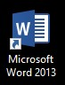
This is an Icon and shortcut to access Microsoft Word, “A word processing programmer for creating CVs, writing letters, and creating brochures

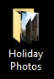
The Desktop you are using may have folders; folders are usually used to keep a bunch of files all in the one place and can be a good way of organising all your documents.

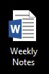
This is a Microsoft Word File, a file you create when using Microsoft Word. For example if you create a letter called Hello Katie using Microsoft Word and then saved it on your

The Taskbar
The Taskbar is the thin strip that runs across the bottom of your screen. It is split into a number of different areas: a Start button, Quick Launch icons, a notification area, and a clock. All other areas are the Taskbar itself. The image below shows the left hand side of the taskbar.

Windows
Explorer:
Sometimes
known as “File Explorer. This allows
you to access the filing system of
your computer where you have
saved files and photos
.

Quick Access Icons:
You can add or
“pin” shortcuts to your favourite
programs to the taskbar so all you
have to do is click on them once and
they’ll open immediately. These will
likely be different on your computer
.

Battery Gauge:
This will show you
how much battery you have left
.

Network:
This will sho
w you if you’re
connected to the internet or not. In
this
image
we
can
see
we’re
connected to a wireless internet

signal. If we were connected by cable
the icon would look like this

and
if we were not connected to the
internet at all it would look like t
his or

Volume:
Click on this and you can adjust the
volume of the speakers

Date And

Time:
Click on this and
you can also view the calendar
.

The Notification Area:
This advises
important
events
you
any
of
happening on your computer such
as updates being added or security
issues.

The Start Menu
The Start Menu is on the Taskbar at the bottom left hand corner of your screen and is where we can access more programs, access settings and turn off your computer.
Left click on Start Menu Icon bottom left of your screen and the start menu will appear. 

File Explorer: This is where you access the filing system of your computer to locate files and folders. You can also access the DVD and Memory Sticks from here.
Power: You can shut down, restart or even make your computer go to sleep with this button.
All apps: This where you can access all the programs/apps on your computer.
Programs: you use the most appear in this pane but can also be pinned here and here on the Start Menu in named groups
Settings: Where you can change the settings of your computer.
Life at a glance: This is where you access things like your calendar, photos, internet browser and email apps.
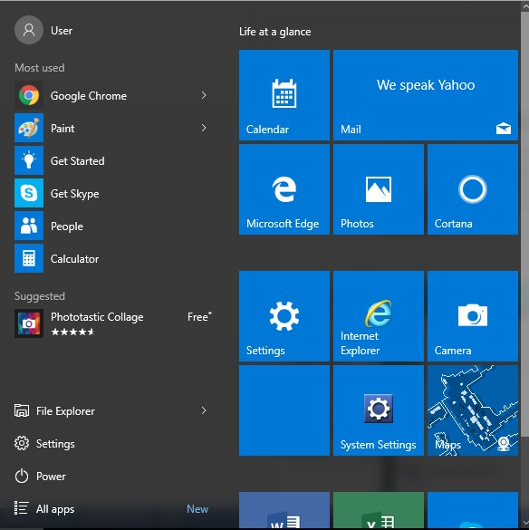
User: This displays the name of
the user logged into the computer.

You can search your computer for a certain program or specific file by simply typing in the name of it after you’ve clicked on the start button. Type Word now and the computer will search for it. A list should appear with “Microsoft Word” as the first result. If you were to click on this it will open up the program (we’ll be doing this later).

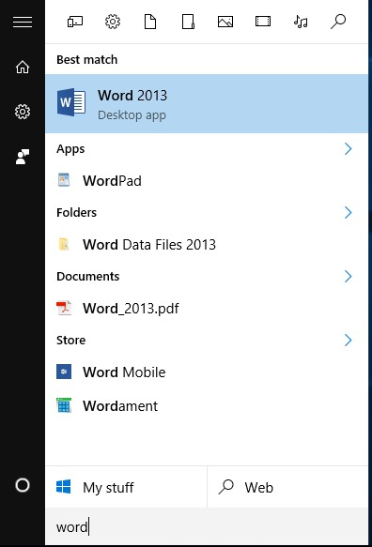

Press the ESC key at the top right of your keyboard once to close the start menu.

Connecting To Wi-Fi
Now will look at connecting to the internet using Wi-Fi or wireless internet. Before going ahead make sure you are in an area where there is Wi-Fi available, you know the name of the network and that you have the password to access it.

Click once on the wireless icon at the bottom right of the taskbar. 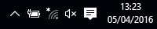

Click once on the network you want to access.

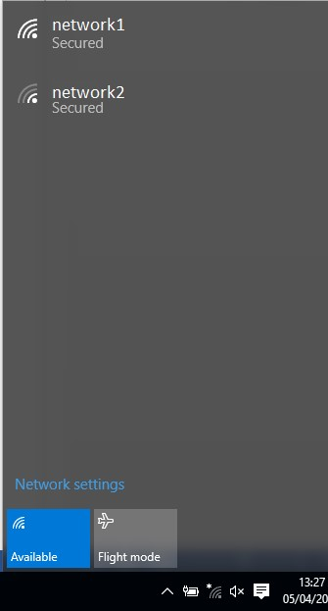

Click once on “Connect”.
(Keep the box for “Connect Automatically” checked as it means you won’t have to do this procedure again to connect to this network.) It may say “Checking Network Requirements” for a few seconds.
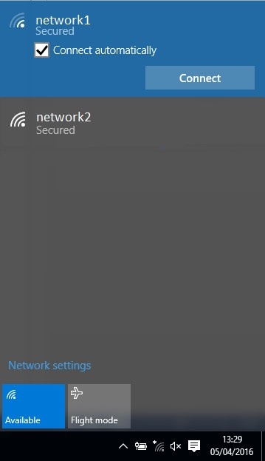

Type in the password (sometimes known as “The Key” or the “WEP”).
You will see that it comes up as little dots. This is for security so that no one looking over your shoulder can see what you’re typing. The click on “Next”.
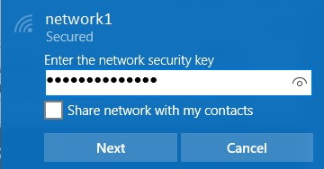

If all the details are correct it should connect in a few seconds.

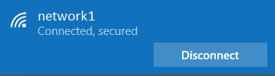
Press the “ESC” key at the top right of the keyboard to come out of the network connections. You are now connected to the internet!

